BOOT-STRAP  
  
  
**Q1:-**  What are the advantages of Bootstrap?  
 **Ans. :-** Bootstrap provides a responsive grid system that automatically adjusts the layout of a website or web application to different screen sizes. This ensures a consistent and optimal user experience across various devices, including desktops, tablets, and smartphones.  
  
Bootstrap comes with a wide range of pre-designed UI components, such as buttons, forms, navigation bars, and more. These components are customizable and can save developers a significant amount of time, as they don't have to create these elements from scratch.  
  
  
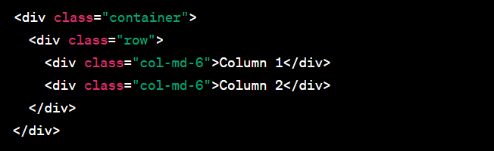

**Q2:-** What is a Bootstrap Container, and how does it work?  
  
ANS:- The **container** class creates a fixed-width container that adapts to different screen sizes based on responsive breakpoints. It provides a responsive layout with a maximum width at each breakpoint.  
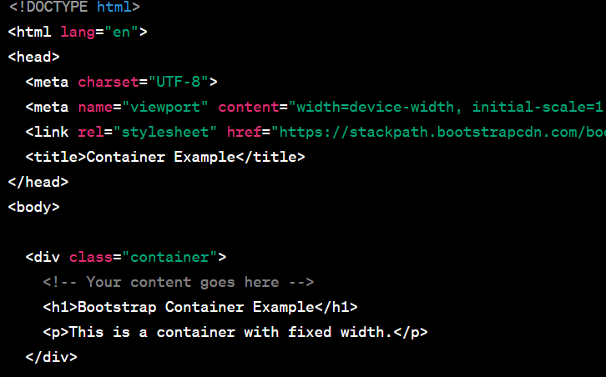

* Q3:- What are the default Bootstrap text settings?  
  ANS:- **.text-left**: Left-aligns the text.
* **.text-center**: Centers the text.
* **.text-right**: Right-aligns the text.
* **.text-justify**: Justifies the text.  
    
  **.text-lowercase**: Converts text to lowercase.
* **.text-uppercase**: Converts text to uppercase.
* **.text-capitalize**: Capitalizes the first letter of each word.

• **.font-weight-bold**: Sets the font weight to bold.

• **.font-weight-normal**: Sets the font weight to normal.  
  
 **.text-primary**, **.text-secondary**, **.text-success**, **.text-danger**, **.text-warning**, **.text-info**, **.text-light**, **.text-dark**, **.text-muted**, **.text-white**: Sets the text color to predefined Bootstrap color classes.

### 

**Q4:-** What do you know about the Bootstrap Grid System?  
 ANS:- The Bootstrap Grid System is a responsive, mobile-first layout system that allows developers to create a flexible and consistent grid-based structure for web pages. It is one of the core components of Bootstrap, providing a set of classes and rules for designing responsive and visually appealing layouts.  
  
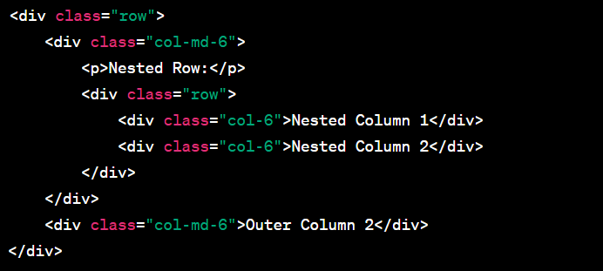

### Q5:- What is the difference between Bootstrap 4 and Bootstrap 5 ANS:- Bootstrap 4:

1. **Flexbox and Grid:**
   * Bootstrap 4 primarily utilizes the Flexbox layout for its grid system.
   * The grid system is based on a 12-column layout.
2. **jQuery Dependency:**
   * Bootstrap 4 relies on jQuery for certain components and functionality.
3. **Utility Classes:**
   * Bootstrap 4 introduced a set of utility classes for quick styling adjustments.
4. **Documentation and Components:**
   * Bootstrap 4 has extensive documentation and a variety of components such as cards, modals, and carousels.

### Bootstrap 5:

1. **Switch to Vanilla JavaScript:**
   * Bootstrap 5 has reduced reliance on jQuery, aiming to move towards a more modern JavaScript ecosystem. It encourages the use of Vanilla JavaScript.
2. **No IE11 Support:**
   * Bootstrap 5 dropped support for Internet Explorer 11 to focus on modern browser capabilities.
3. **Customizable Reset:**
   * Bootstrap 5 introduced a customizable CSS reset, allowing developers to tailor the reset styles based on project requirements.
4. **Updated Grid System:**
   * Bootstrap 5 maintains a 12-column grid system but introduces a new "gutter" variable for better control over column spacing.
5. **Sass Compilation:**
   * The switch from Less to Sass for stylesheets compilation.
6. **New Components:**
   * Bootstrap 5 introduces new components, such as off-canvas navigation and improved accordion functionality.

**Q6:-** What is a Button Group, and what is the class for a basic Button Group?  
ANS:- A Button Group in Bootstrap is a set of buttons grouped together for styling and layout purposes. It allows you to apply common styles to a collection of buttons and ensures they appear visually connected. Button groups are useful for creating segmented controls or toolbars where related actions are grouped together.  
  
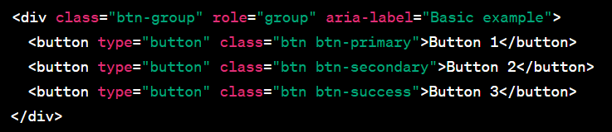

**Q7:-** • How can you use Bootstrap to make thumbnails?  
 ANS:- In Bootstrap, you can use the **.thumbnail** class to create image thumbnails with optional captions. Thumbnails are typically small images that can be used for a gallery or to showcase a collection of images.  
  
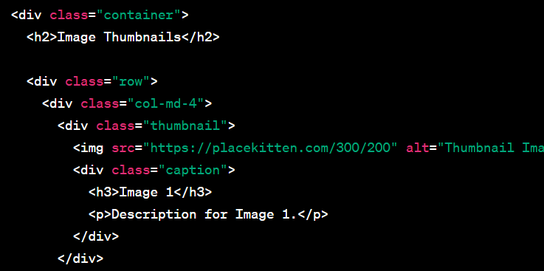

**Q8:-** In Bootstrap 4, what is flexbox? **ANS:-** In Bootstrap 4, the Flexbox (Flexible Box Layout) model is a key component used for creating flexible and responsive layouts. Flexbox is a layout model that allows you to design complex, dynamic, and resizable layouts with ease. It provides a more efficient way to distribute space and align items within a container, especially when dealing with different screen sizes and devices.  
  
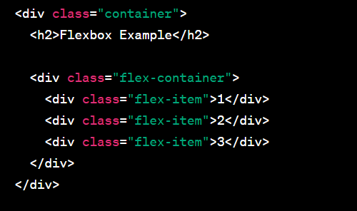

**Q9:-** How can one create an alert in Bootstrap?  
ANS:- In Bootstrap, you can create alerts using the **.alert** class along with additional contextual classes to define the style of the alert (e.g., **.alert-success**, **.alert-danger**)  
  
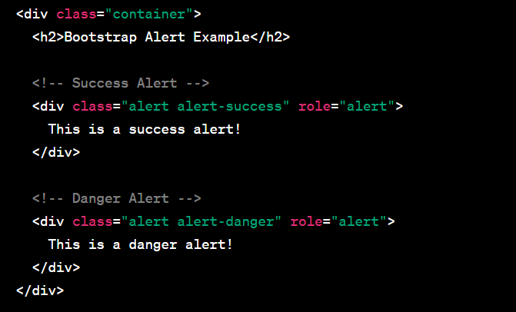

**Q10:-** What is a bootstrap card and how would you create one?  
ANS:-   
In Bootstrap, a card is a flexible and extensible container that can hold various types of content. It's a versatile component commonly used to display information, images, and other elements in a structured and visually appealing way. Cards are part of Bootstrap's grid system, making them easy to integrate into responsive layouts.  
  
